H.T No
Regulations:
A17

Sreenidhi Institute of Science and Technology
(An Autonomous Institution)
Code No: 6AC41 Date: 04-Mar-2023 (FN)

B.Tech II-Year II- Semester External Examination, February/March-2023 (Supplementary)
Elements of Electrical Engineering (CSE and IT)

Time: 3 Hours Max.Marks:75
Note: a) No additional answer sheets will be provided.
b) All sub-parts of a question must be answered at one place only, otherwise it will not be valued.
c) Missing data can be assumed suitably.

Bloom's Cognitive Levels of Learning (BCLL)

Remember | L1 | Apply | L3 | Evaluate | L5
Understand | L2 | Analyze | L4 | Create | L6

Part - A Max.Marks:25

Answer all QUESTIONS.
 |  | BCLL | CO(s) | Marks
1 | Two resistances, one of 30 ohms and another of unknown value are connected in parallel, the total power dissipated in the circuit is 450 watts, when the applied voltage is 90 volts. Estimate the value of unknown resistance. | L2 | CO1 | [2M]
2 | Define phase and phase difference. | L1 | CO2 | [2M]
3 | Compute EMF equation of DC Generator with their notations. | L2 | CO3 | [2M]
4 | Name the essential parts of a transformer . | L1 | CO4 | [2M]
5 | Outline the types of induction motor. | L1 | CO5 | [2M]
6 | List the basic instruments. | L1 | CO6 | [3M]
7 | Define thevenin's theorem. | L1 | CO1 | [3M]
8 | Recall the function of commutator in DC Machine. | L1 | CO3 | [3M]
9 | Describe the range of ammeter can be extended. | L1 | CO5 | [3M]
10 | Define form factor and peak factor. | L1 | CO2 | [3M]

Part – B Max.Marks:50
ANSWER ANY FIVE QUESTIONS. EACH QUESTION CARRIES 10 MARKS.

 |  |  | BCLL | CO(s) | Marks
11. | a) | Solve the currents in different branches of the network shown in figure using nodal analysis  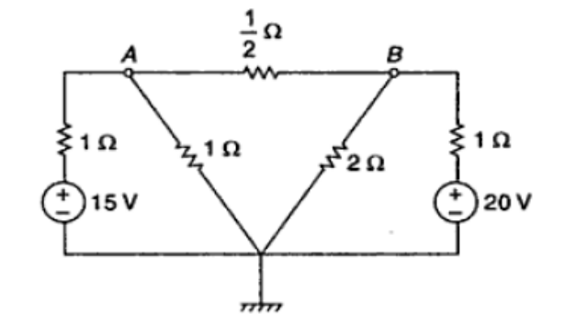 | L3 | CO1 | [5M]
 | b) | Calculate the equivalent resistance between terminals x-y in the resistance network shown in Figure below by using Y- Δ transformation.  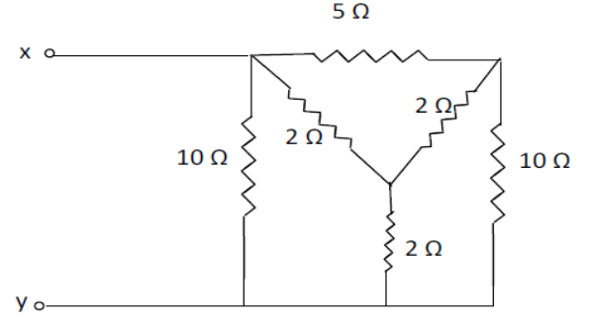 | L3 | CO1 | [5M]
12. | a) | Compute the expression for RMS value of alternating current wave  I = Im Sin ωt | L3 | CO2 | [5M]
 | b) | A coil of 50Ω and 0.5H is connected across 200V, 50Hz supply. Solve  i) Circuit impedance, ii) Current,  iii) Power factor, iv) Active and reactive power. | L3 | CO2 | [5M]
13. | a) | Explain the principles of operation of DC generators. | L2 | CO3 | [5M]
 | b) | Explain speed torque characteristic of dc shunt motor. | L2 | CO3 | [5M]
14. | a) | Explain the principle of operation of a single transformers. | L2 | CO4 | [5M]
 | b) | A 50 kVA, 1000/10000 V, 50Hz single phase transformer has iron loss of 1200W and copper loss is 500 W. Calculate the efficiency at  i) 50 % at unity power factor ii) 100 % of normal load at power factor of 0.8. | L3 | CO4 | [5M]
15. | a) | Explain with neat sketch the constructional details of a three phase induction motor. | L2 | CO5 | [5M]
 | b) | If the e. m.f. in the stator of an 8-pole induction motor has a frequency of 50Hz and that in the rotor 3/2 Hz,  calculate i) the slip and ii) the speed of motor | L3 | CO5 | [5M]
16. | a) | Sketch and Explain the operating principle of PMMC type instrument. | L2 | CO6 | [5M]
 | b) | List the advantages and disadvantages of PMMC instrument. | L1 | CO6 | [5M]
17. | a) | Define the following  i) Linear and Non linear  ii) Active and Passive | L1 | CO1 | [4M]
 | b) | When a current of 2mA is supplied to a coil with 100 turns, a magnetic flux of magnitude 0.2Wb is linked with it. Solve the self-inductance of this coil. | L3 | CO2 | [3M]
 | c) | Explain the various losses in DC Machines. | L2 | CO3 | [3M]
18. | a) | Distinguish between Ideal and practical transformer. | L2 | CO4 | [4M]
 | b) | Compute the relationship between the line voltage, phase voltage, line current and phase current in a three phase star connected circuit. | L2 | CO5 | [3M]
 | c) | Distinguish between the spring control and gravity control. | L2 | CO6 | [3M]

-- 00 -- 00 –

